Microsoft Teams Information
Microsoft Teams is a full-featured collaboration and messaging tool provided with your Penn Highlands Office 365 account. This article will outline the basics of getting the Teams installed on your computer or mobile device, and will get you acquainted with the basics of how to use Teams.

Contents
- What is Microsoft Teams?
- How do I get Teams?
- Sign In and Getting Started with Teams
- Pick a Team and Channel
- Chat and Share Files in Teams
- Collaborate in Teams
- Start Chats, Calls, and Meetings
- Scheduling and Recording a Meeting in Microsoft Teams

What is Microsoft Teams?
Click here to find out “What is Microsoft Teams?” in a short video about Teams and its features.
You may also copy the following link into your browser: https://www.microsoft.com/en-us/videoplayer/embed/RE1LGec?pid=ocpVideo0-innerdiv-oneplayer&postJsllMsg=true&maskLevel=20&market=en-us

How do I get Teams?
PC/Mac: Navigate to the following website and click the link appropriate for your operating system: https://teams.microsoft.com/downloads
iOS: Download the Teams app from the App Store: https://aka.ms/iosteams
Android: Download the Teams app from the Play Store: https://aka.ms/androidteams
Web Browser: You are also able to use web browser version of Teams which is fully featured and best experienced with Chrome or Edge browsers.
You can navigate to Teams on the web at: https://teams.microsoft.com
Note: Teams is part of Office 365 and as a Faculty, Staff, or Student you are licensed to use it.

Sign In and Getting Started with Teams
Sign in to Teams
- Start Teams.
  - In Windows, click Start > Microsoft Corporation > Microsoft Teams.
  - On Mac, go to the Applications folder and click Microsoft Teams.
  - On mobile, tap the Teams icon.
- Sign in with your Penn Highlands email address and password.
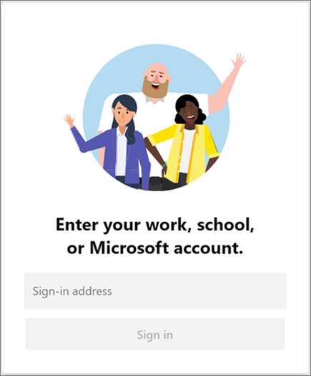

Pick a Team and Channel
A team is a collection of people, conversations, files, and tools — all in one place. A channel is a discussion in a team, dedicated to a department, project, or topic.
The best way to get familiar with teams and channels is to pick a team and channel and start exploring!
- Select Teams on the left side of the app and then pick a team.
- Select a channel and explore the Conversations, Files, and other tabs.
For more info, see Teams and channels.
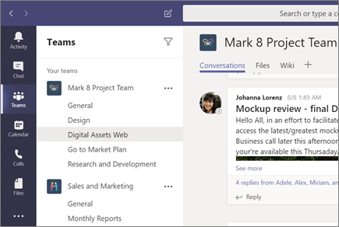

Chat and Share Files in Teams
Start a new conversation with a person or group
- At the top of the app, click New chat .
- In the To field, type the name of the person or people you want to chat with.
- In the compose box, say what you have to say and click Send .
Reply to a conversation
Channel conversations are organized by date and then threaded. The replies in threads are organized under the initial post so it's easier to follow multiple conversations.
- Find the conversation thread you want to reply to.
- Click Reply, add your message, and click Send .
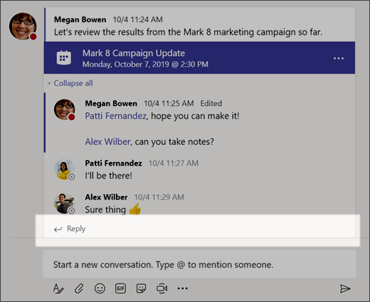

Have fun with emoji, memes, and GIFs
Express yourself and impress your classmates!
- Click Sticker under the box where you type your message, then pick a meme or sticker from one of the categories.
The Sticker catalog contains a wide variety of customizable stickers and memes—you can even upload your own! Check out Emoji for smiley faces and GIF for animated GIFs.
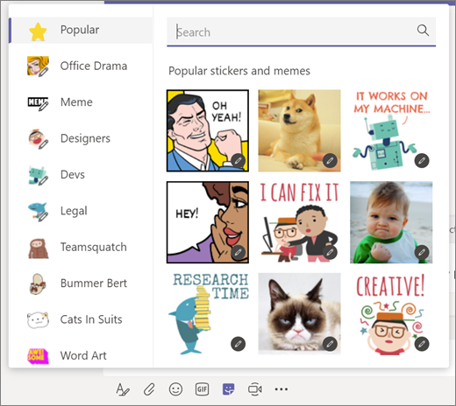

Share a file
Sometimes words aren't enough, and you need to post a file to a channel conversation.
Tip: Teams works particularly well with Microsoft Office documents.
- In your channel conversation, click Attach beneath your compose box.
- Select a file, click Open, and then Send .

You can always see all the files you post to a channel by going to the Files tab.
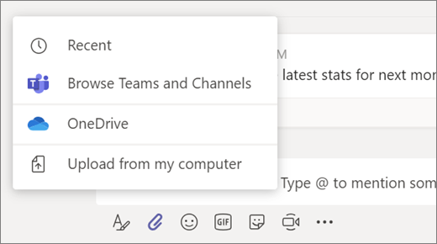

Collaborate in Teams
@mention someone
An @mention is like a tap on the shoulder—a way to get someone's attention in a channel conversation or a chat.
- In the compose box, type @, then type the first few letters of the person’s name. You can also @mention entire teams and channels.
- Select the person. Repeat for as many people as you want to @mention.
Each person you @mention gets a notification in their Activity feed. Check for a red circle next to Activity right now to see if someone has @mentioned you!
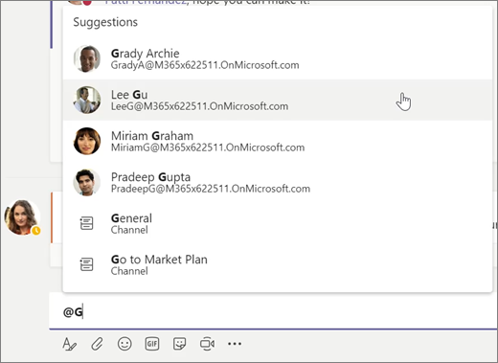

Stay on top of things
Notifications let you know when someone @mentions you, likes something you’ve posted, or replies to a thread you started. The Activity feed helps you stay on top of all your notifications.
- Click Activity .
- Feed shows you a summary of everything that's happened in the channels you follow.
  - Click Filter to show only certain types of notifications such as @mentions or likes.
  - Select Feed > My Activity to see a list of everything you've been up to lately in Teams.
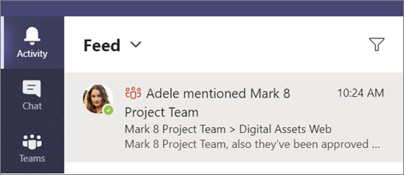

Search for messages, people, or files
Searches cover your entire organization—all the channels that you're part of.
- Type a phrase in the command box at the top of the app and press Enter.
- Select the Messages, People, or Files tab.
- Select an item in the search results. Alternatively, you can click Filter to further refine your search results.
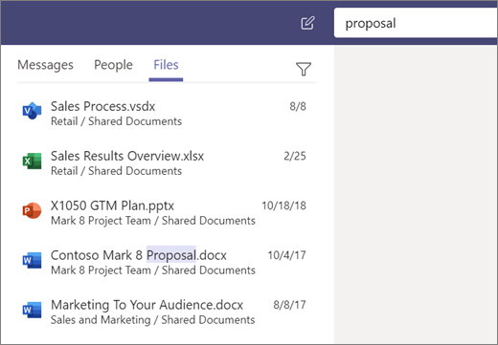

Start Chats, Calls, and Meetings
Please view the video at the link below for information on starting chats, calls, and meetings in Teams
Start Chats, Calls or Meetings

Scheduling a Meeting
1. Launch the Teams client and click the Meetings tab on the left-hand navbar.
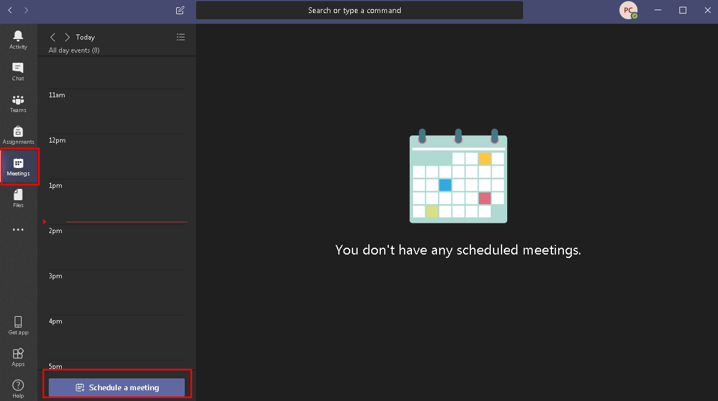

2. Fill out your meeting details on the next screen. Students can ignore the "Select a channel to meet in" and "Location" dropdowns as these features are not available to students.
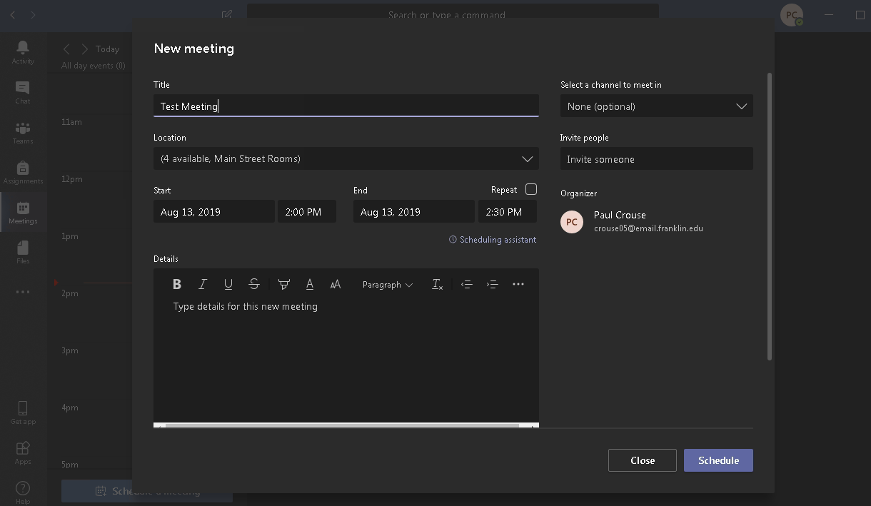

3. Fill in the email addresses of your attendees on the right and click Schedule when you are satisfied.
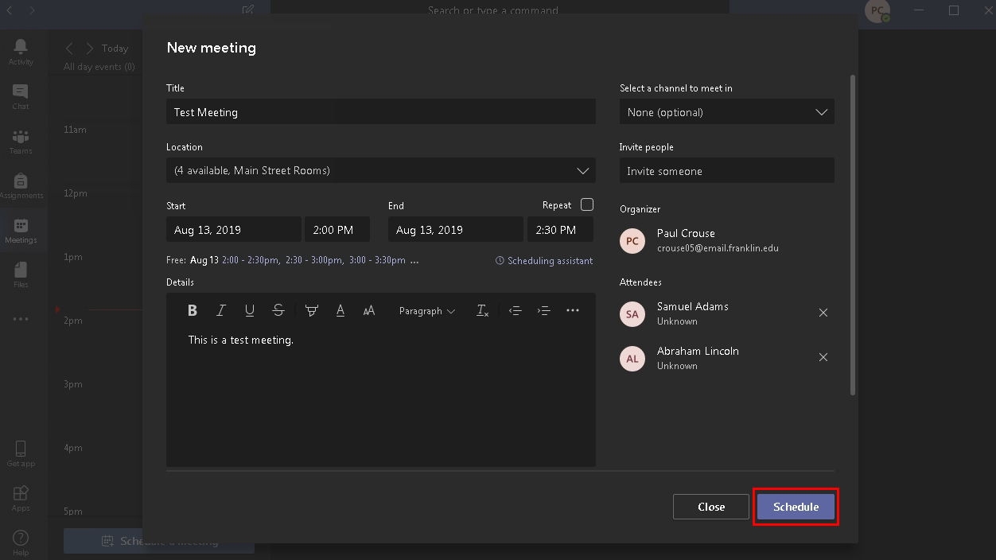

4. You'll then be taken back to the Meetings tab, and you'll be able to navigate through the calendar interface and see and select your meeting. This meeting should also be visible in your calendar within your email located at https://webmail.pennhighlands.edu
When the time for the meeting has arrived, select the meeting by clicking on it in the calendar view and then click the Join button in the top right. This will join the meeting.
