Tutor.com
Tutor.com is a FREE online tutoring service available to all Penn Highlands students that is available 24/7. Tutor.com is incorporated into your Brightspace course and is accessed via the Resources tab: https://learn.pennhighlands.edu/d2l/home
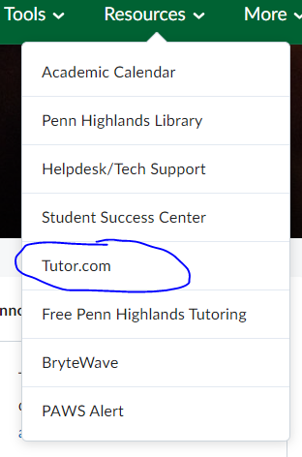Options for tutoring include:

In addition to scheduling a tutor appointment, meeting with a tutor immediately, or submitting a paper for review, you have access to many test preparation and subject study resources:
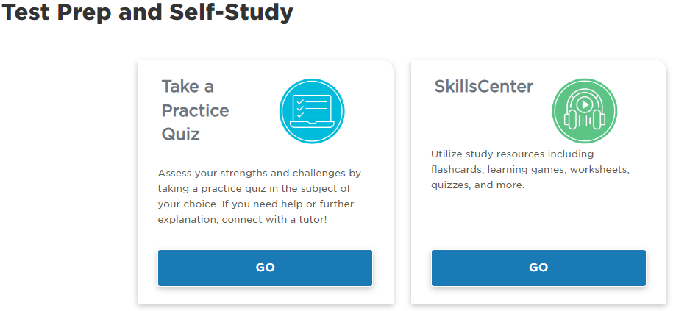
Penn Highlands also provides face-to-face tutoring in the Writing/Math Center at the Richland Campus, Room B115 and scheduled drop-in tutoring at each campus when available. Please contact the Student Success Center at 814-262-6451 or studentsuccess@pennhighlands.edu for more information. You may also access the up-to-date tutoring schedule including center locations on the Student Support tab of myPEAK under Tutoring: https://my.pennhighlands.edu/ICS/Student_Support/Tutoring.jnz

